Laporan Aktivitas 3.1
Berdasarkan hasil pengujian pada aktivitas 3.1, lengkapi tabel dibawah ini sebagai laporan hasil aktivitas.
Tabel1. 4 Pear to pear Connection network
End device | Network Interfaces | Network Interfaces Pengganti | Ip address | Subnet mask | network | Media Kabel | Pengujian
PCLAN1 |  |  |  |  |  |  | IP sunber :  …………………..  Ping IP Address Tujuan...............  ...........................  Hasil...................  ...........................
PCLAN2 |  |  |  |  |  |  | IP sunber :  …………………..  Ping IP Address Tujuan...............  ...........................  Hasil...................  ...........................

Tabel1. 5 Laporan menghubungkan tige buah end user device
End device | Network Interfaces | Network device & Port | Ip address | network | Media Kabel | Pengujian
PCLAN2 |  |  |  |  |  | IP sumber :  Ping IP Address Tujuan...............  ...........................  Hasil...................  ...........................  Ping IP Address Tujuan...............  ...........................  Hasil...................  ...........................
PCLAN2 |  |  |  |  |  | IP sumber :  Ping IP Address Tujuan...............  ...........................  Hasil...................  ...........................  Ping IP Address Tujuan...............  ...........................  Hasil...................  ...........................
LaptopLAN2 |  |  |  |  |  | IP sumber :  Ping IP Address Tujuan...............  ...........................  Hasil...................  ...........................  Ping IP Address Tujuan...............  ...........................  Hasil...................  ...........................

Tabel1. 6 Menguji Switch VLAN Port Member
Catatan : isi tabel hanya pada kolom Sumber Pengujian LaptopLAN2
Network Device | VLAN ID & VLAN Name | Interface/Port member | End Device | IP Address | Sumber Pengujian  LaptopLAN2
SwitchLAN1 | Vlan id :.2  Name : LAN1. | FastEthernet0/1 | PCLAN1 | 192.168.1.1 | 192.168.1.1  Hasil:  ....................................................  192.168.1.2  Hasil:  ...................................................
SwitchLAN1 | Vlan id :.2  Name : LAN1. | FastEthernet0/2 | PCLAN2 | 192.168.1.2
SwitchLAN1 | Vlan id :.2  Name : LAN1. | FastEthernet0/3 | - | -
SwitchLAN1 | Vlan id :.3.  Name : LAN2 | FastEthernet0/4 | - | -
SwitchLAN1 | Vlan id :.3.  Name : LAN2 | FastEthernet0/5 | - | -
SwitchLAN1 | Vlan id :.3.  Name : LAN2 | GigabitEthetnet0/1 | LaptopLAN2 | 192.168.1.3
SwitchLAN1 | Vlan id :.2  Name : LAN1. | FastEthernet0/1 | PCLAN1 | 192.168.1.1 | 192.168.1.1  Hasil:  ....................................................  192.168.1.2  Hasil:  ...................................................
SwitchLAN1 | Vlan id :.2  Name : LAN1. | FastEthernet0/2 | PCLAN2 | 192.168.1.2
SwitchLAN1 | Vlan id :.2  Name : LAN1. | FastEthernet0/3 | LaptopLAN2 | 192.168.1.3

Tabel1. 7 Router To Router Routing Static
Sources  Network Device | Interfaces/ Port | IP adress  gateway | Destination  Network Device | IP Address | Static  Routing
Router LAN1 | FastEthernet0/0 | ..................... | PCLAN2 | ..................... | .....................  ....................
Router LAN1 | FastEthernet0/1 | .................... | LaptopLAN2 | .................... | .....................  ....................
 |  |  |  |  | ....................
Router LAN1 | FastEthernet1/0 | .................... | RouterLAN2 | .................... | ....................
Router LAN2 | FastEthernet0/0 | .................... | PCLAN1 | .................... | ....................  ....................
Router LAN2 | FastEthernet0/1 | .................... | ServerLAN1 | .................... | ....................  ....................
....................
....................

Tabel1. 8 Perangkat keras jaringan dan fungsi
No | Simbol Logic Perangkat keras Jaringan | Nama Perangkat | Fungsi
 | 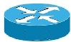
 | 
 | 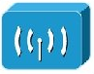
 | 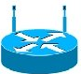

Tabel1. 9 Media kabel jaringan dan fungsi
Media Kabel
No | Simbol logic dan media Fisik kabel jaringan | Nama Kabel | Fungsi
 | 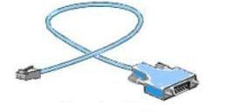
 | 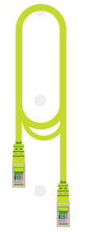
 | 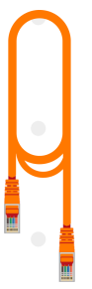
 | 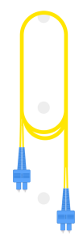
 | 
 | 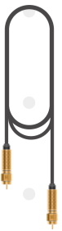
 | 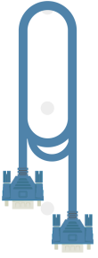
Sumber gambar cisco packet tracert https://www.netacad.com/courses/packet-tracer

